Cloud & DevOps – Connect AWS EC2 instance using PUTTY

**Launch an EC2 Instance:**

Steps:

1. Launch an EC2 instance using AWS console by clicking launch instance.

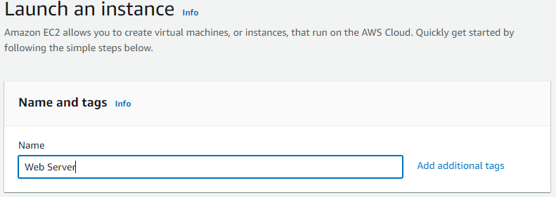

1. Application and OS images section select amazon linux free tier eligible

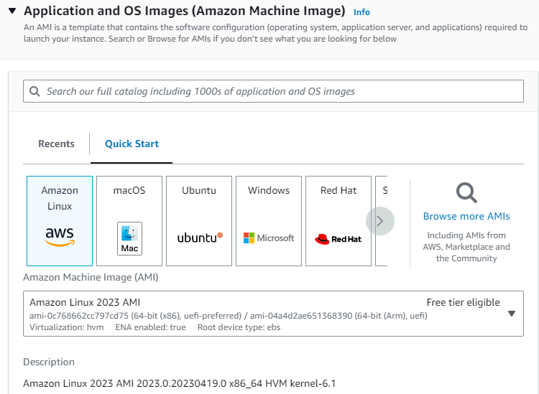

1. Instance type section select t2 micro family free tier eligible

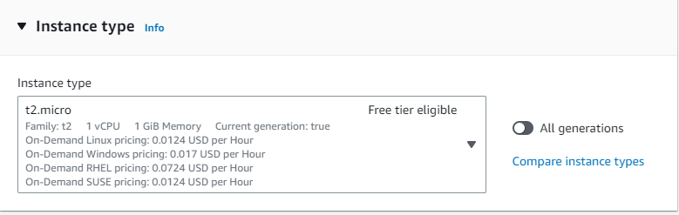

1. Key-pair section need to create .ppk file used to connect an EC2 via Putty

You can use a key pair to securely connect to your instance. Ensure that you have access to the selected key pair before you launch the instance.

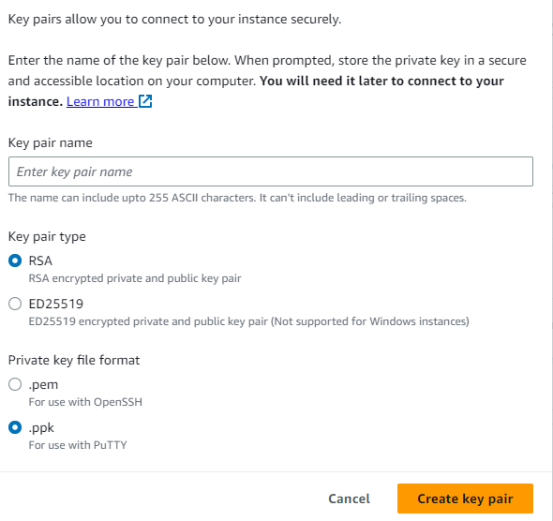

1. Network Settings section used to select the required network settings to access or deny the EC2 instance. Firewall (security group) settings for the instance. Enable SSH connection to connect the ec2 instance secure manner and HTTP enabled to access the application page over the web by using HTTP protocol.

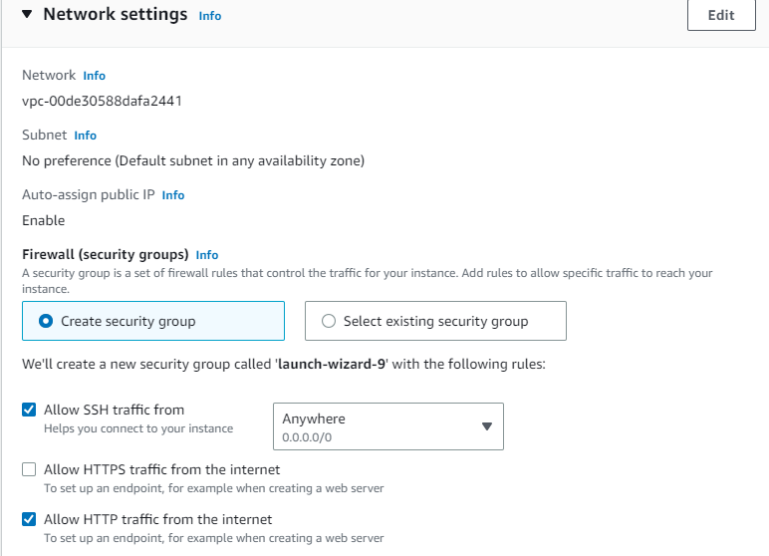

1. Configure Storage system for the particular EC2 system, below is the default volume for free tier eligible.

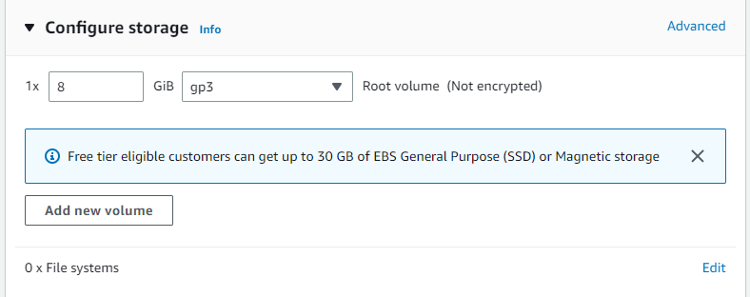

1. Advanced details section contains advance information and configuration details for the instance like metadata settings and user data details etc…

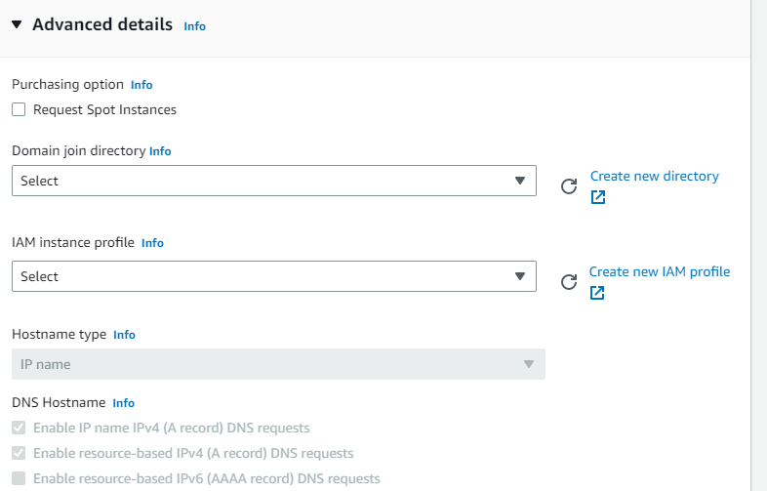

1. Click launch instance and wait for few min for the instance up and running, find the below screen our launched instance is up and running.

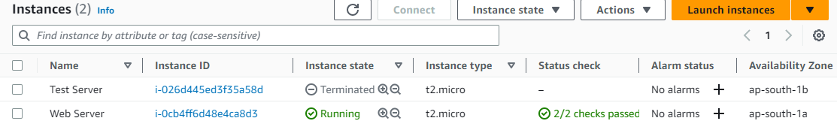

1. Take the public-ip of the EC2 instance and try to hit the browser hope you will get default html page gets loaded from the server. File path reference (/var/www/html/index.html)
2. Hence we conclude that our launched instance is up and running and the server is ready for further use.

**Connect an EC2 instance using Putty.**

Steps:

1. Download putty software and install into your desktop.
2. Enter public-ip of your EC2 instance in the host name column and Saved session column you give your specified name, then choose connection category and select SSH under that Auth column there is an credential for authentication, hence select the .ppk file which you have download during launch instance and configure that file in it and save the server/instance.

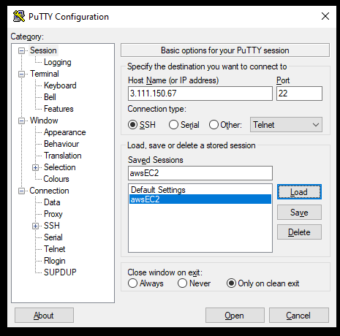

1. Once done the above steps then try to load the details of EC2 instance in Putty and click open hence you successfully connected an EC2 Instance.

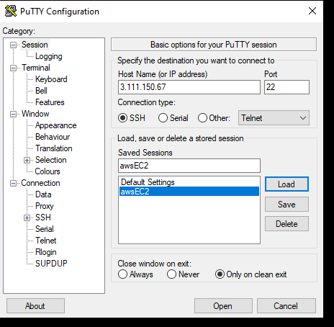

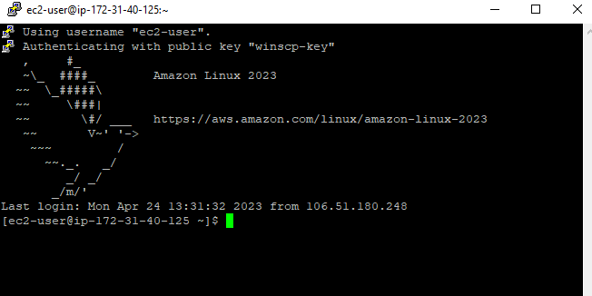

1. Check you can able to navigate in to the folder by using Linux command and do perform some operation.
2. Keep do some exercise if required and terminate the session by closing the putty and try to re-login again for your experience.

Note – If you want to switch to root user – Use > sudo su in command line to connect root user.

**Connect an EC2 instance using WINSCP:**

It’s a windows UI tool used to connect EC2 instance and perform the operation by using drag and drop.

Steps:

1. Download winscp software and install into your desktop.
2. Enter public-ip of your EC2 instance in the host name column and click advanced button and choose SSH column under authentication tab select the required .ppk file and save the same and click to save the session by providing the required name by own.

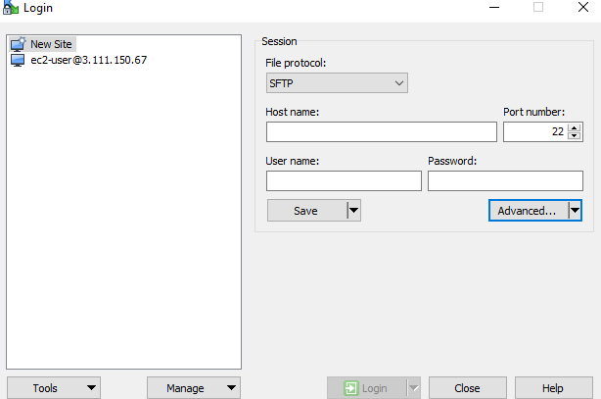

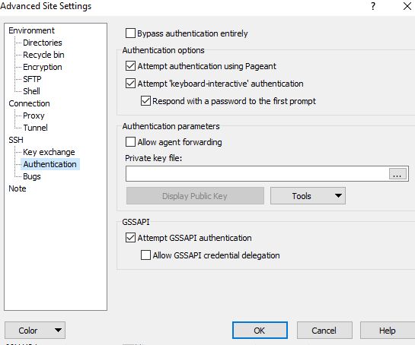

1. Once the above steps done try to load the configured session as like below in winscp tool and check the details.

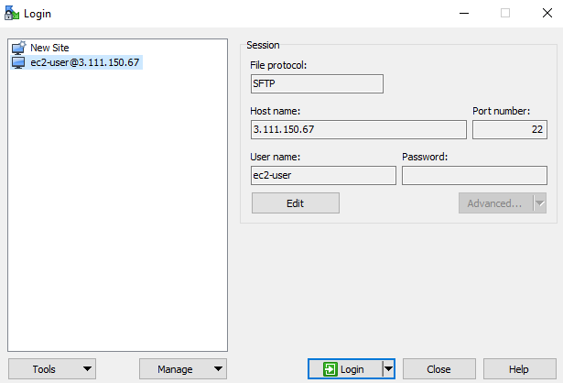

1. Once the above steps done try to open the session and able to connect the server successfully as like below.

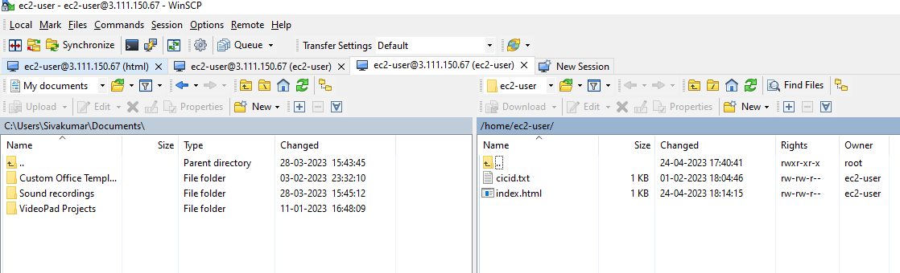

1. Try to check and close the session again and open also drag and drop some folder and files based on your use case.

Thanks for your co-operation.

Happy Learning.